3. Civil Construction Works for Contract Package TNRSP 03

1 | Contract Package | : | TNRSP 03
2 | Name of work | : | Upgradation of Road from Ramanathapuram to Kattumavadi
3 | Name of Contractor | : | Larsen & Toubro Limited
4 | Name of Consultant | : | Sheladia Associates Inc.,
5 | Original Contract value | : | Rs.143,40,92,979/-
6 | Variation Approved /Proposed | : | Rs. 656393571 /- (45.771 %)
 | Total | : | Rs. 2090486550.51/-
7 | Total length of Project Road | : | 99.8Km
8 | Physical progress | : | Achieved 100%
9 | Financial progress | : | Achieved 99.65 %
10 | Expenditure incurred | : | 128.95% (includes price escalation )
11 | Expected Final contract value | : | 19740 lakhs
12. | Upto date value of work done | : | 19740 lakhs
13 | Remaining work | : | nil

Status

Section | Length | Date of Start | Scheduled date of Completion | EOT granted if any | Remarks
1 | 19.00 | 10/02/2005 | 09/08/2006 | Encumbrances free 11.90 Kms upto 05/05/2008 & balance length upto 04/07/2008 | 13.126 Kms has been substantially completed on 05th May 2008 & Taking Over certificate issued. Remaining 5.80 Kms has been substantially completed on 4th July 2008 & Taking Over Certificate issued. (490+210 to 509+126 (18.926 km). DLC issued on 05 May 2009.
2 | 25.90 | 10/08/2005 | 08/04/2007 | 05/05/2008 | Section 02 has been substantially completed on 05th May 2008 & Taking Over certificate issued (464+000 to 489+600 (25.60 km) DLC issued on 05 May 2009  Taking over certificate for Bridge no. 102 ( Including approaches) issued on 31 July 2009.
3 | 23.50 | 10/12/2005 | 09/06/2007 | 30/08/2008 | Section 3 substantially completed.  Taking over certificate issued to the Contractor.DLC issued on 20 Sep.09
4 | 31.50 | 10/05/2006 | 09/02/2008 | 31/01/2009 | Section 4 substantially completed.  Taking over certificate (on substantial completion) issued to the Contractor(31/1/09)

Road Works: (Full width)

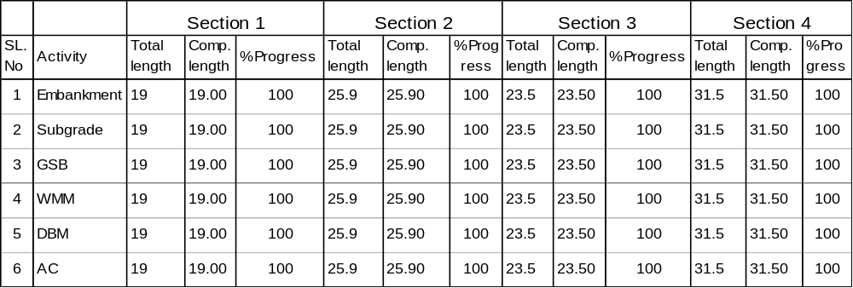

Culverts

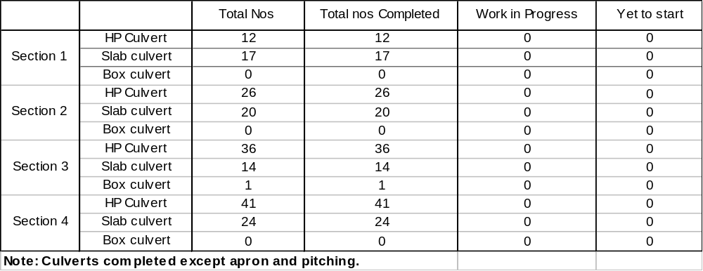

Bridges (New Construction):
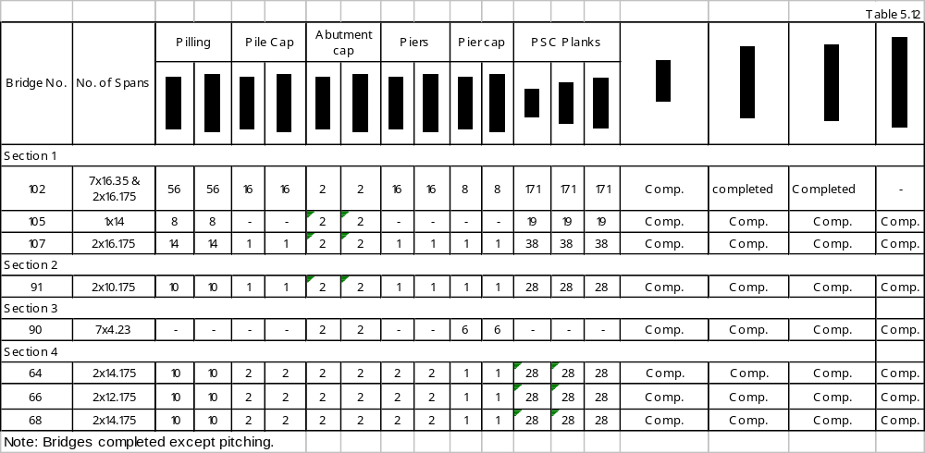

Bridges (Rehabilitation of existing bridges)

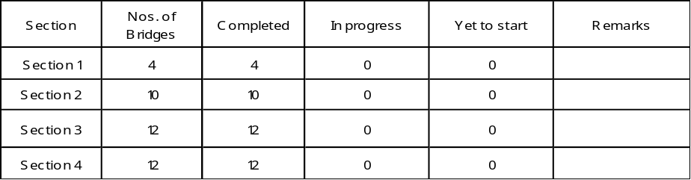

Encumbrance

Nil

Payment details of Contractor in lakhs)

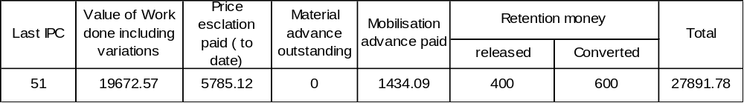

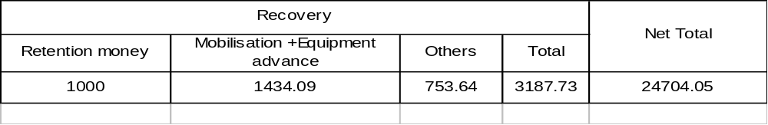

Pending issues with Employer


